**Question#1**

* Write a program to take an array and find the number of occurrences each number had. The  
  output should be something like this:

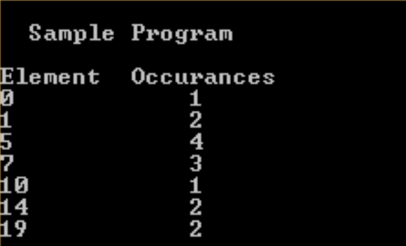

NOTE: Sort the array elements first and then calculate the frequency of each element. Use  
single for-loop to calculate the frequency of each element.

**Question#2**

Find the persistence of a number. It is the number, if times you can multiple the digits (iteratively) before you get a single digit number.  
EXAMPLE:

4*6*7=168  
1*6*8 = 48  
4*8 = 32  
3*2 = 6  
4 steps

the persistence of 467 is 4  
  
The persistence of 5 is 0.